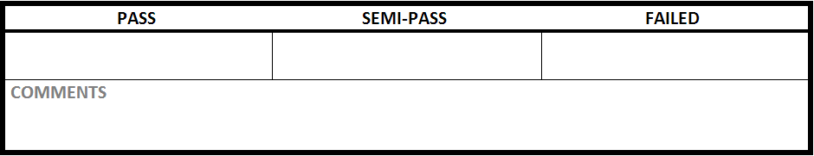

|  |  |
| --- | --- |
| Test Case #:LGN1.3 | Test Case Name:Login |
| System: Rec Warehouse | Subsystem:Login |
| Designed by: Rec Team | Design Date: October 2013 |
| Executed by: | Execution Date: |

|  |
| --- |
| Short Description: login in with incorrect information |

|  |
| --- |
| Preconditions:at the login screen |

|  |  |  |  |  |
| --- | --- | --- | --- | --- |
| Step | Action | Expected System Response | Pass/Fail | Comment |
| 1 | enter ‘hacker’ into username | displays hacker in username |  |  |
| 2 | enter ‘0000’ into password | displays **** in password |  |  |
| 3 | click login | displays error message indicating the login information was incorrect |  |  |

|  |
| --- |
| Postconditions:at the login screen |